

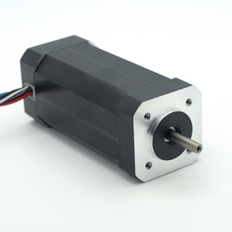

42mm Brushless DC Series

**SPECIFICATIONS:**

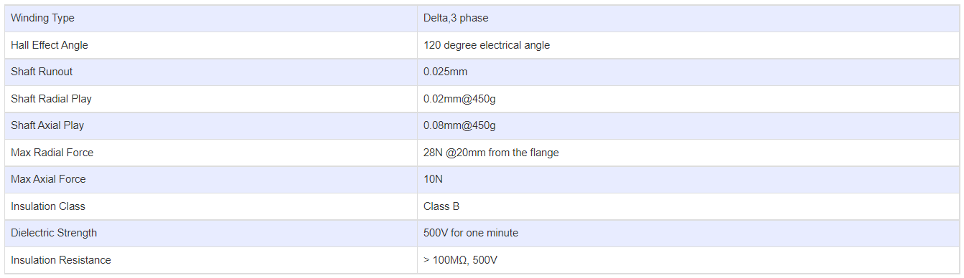

**SUBMODELS:**

*The following are common sub models for the LDO-42BL series. Click to request a quote and/or more information on a specific sub model.*

